Production:EMI:SPECIAL PROJECTS:EMI_Internal_CreativeServices:CARINNS00001WEB_Caring_Transitions_Logo_branding:Letterhead:Letterhead PDFs:CT_Letterhead_Final_Bleed.pdf

**Sue needed to clear a home covered in sheets—and dust. Some rooms had not been used in decades. It was an overwhelming task that pushed her to consider a dumpster! But we found this humble home in Lombard hid a treasure trove of pristine vintage women’s clothing, over 200 elegant hats, and accessories.**

**We conducted an online auction AND an flash estate sale. Buyers waited overnight for the sale that began at noon!**

**The sale was a huge success and the house was left in broom swept condition—ready for market.**

**Call us before you toss anything!**

**You could have a treasure trove too.**

Overwhelmed with cleaning out a home? Don’t toss the Vintage!

 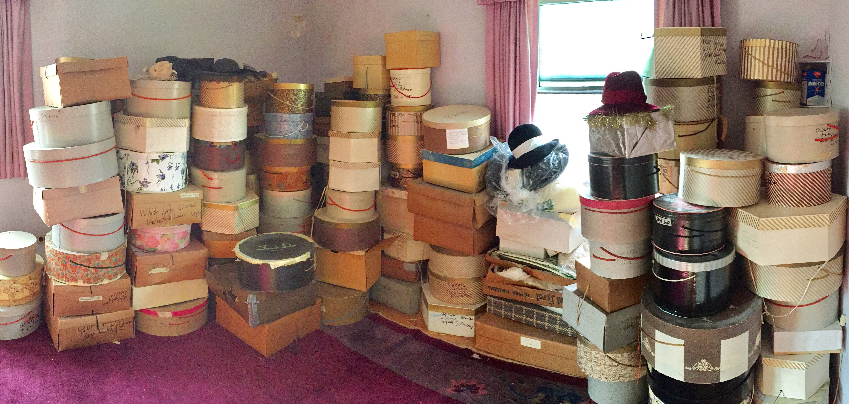

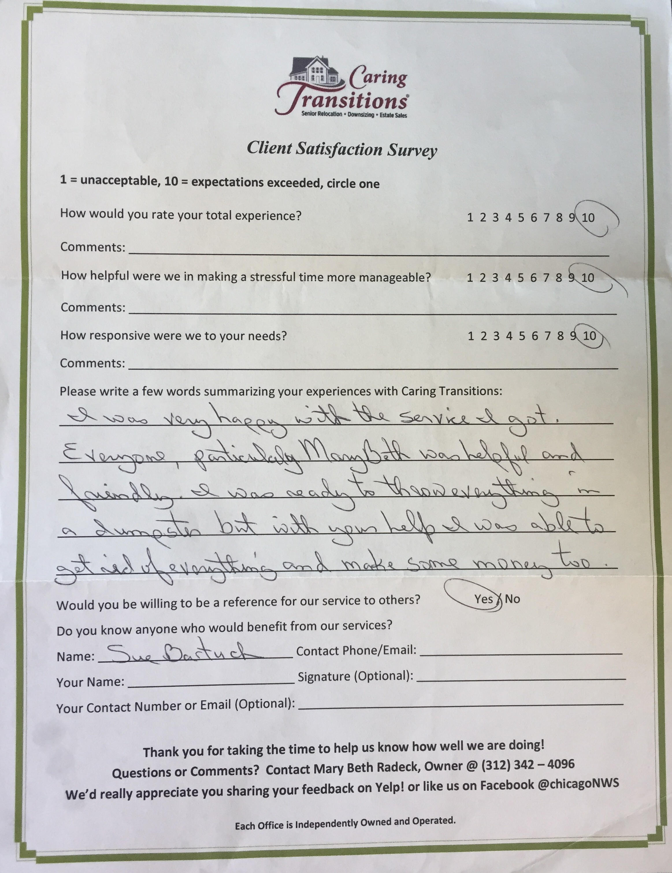

**Caring Transitions Chicago Northwest Suburbs**

836 S. Arlington Heights Road, #133, Elk Grove Village, IL 60007

630-333-9366 • www.CaringTransitionsChicagoNWS.com